Project: Dengue Prediction using ML algorithm  
Project Description:

I need a system which can predict dengue cases using dengue cases, climate, vegetation and population data variables. The system should be able to analyse data and generate graphs to the web application using **Python 3**.

This is the mockup that i need for the system:  
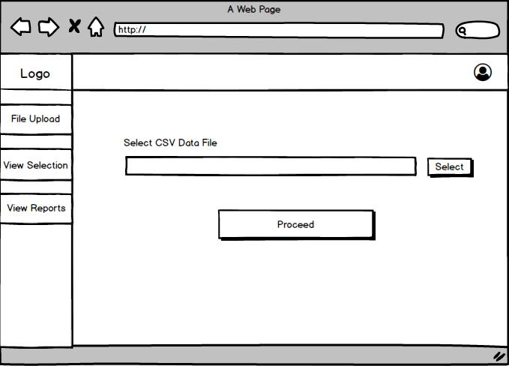

These are the main features.steps that you have to do in the application:

1. Data preprocessing and Cleaning parts(can you tell the procedures you follow)
2. With acceptable accuracy prediction part using XG boost(the core code part)
3. Generate some data analysing graphs in a meaningful way
4. Also show previous results graph on the dashboard as well
5. Dashboard with user login
6. Dashboard with user registration
7. User input page for data to generate predictions

For database you can use anything in which you are comfortable. For website, you have to use Flask. I want first 3 points with some graph implementation on dashboard untill 24th April.

**Dataset**:

I have an imbalanced data set where I have weekly dengue and climate data from year 2009-2014 , weekly vegetation index data from 2013-mid of 2014 , and annual population data from 2009-2014. In veginices-col the VEG2 col is an average value the real value is in VEG1. I also attached dataset with its description. Please go through that as well.

there are some missing data for 2 weeks in dengCol.csv and for all the data variables I have data only from 2013 to mid 2014. You can do anything with the data if you can manage to get good accuracy. For your information 37th and 38th week data are the missing values in dengCol.csv for year 2013.

I have an imbalanced data set where I have weekly dengue and climate data from year 2009-2014, weekly vegetation index data from 2013-mid of 2014 , and annual population data from 2009-2014

it doesn't matter that what you will do with the dataset, you just handle the data according to your way to get good results no worries on that.

For the technique, you can use XG boost algorithm or any other algorithm you prefer to get the maximum accuracy.

For the graphs, i want the graphs with the time ranges and dengue case predictions mainly.

I hope you understood about the project. If you have questions feel free to ask and also let me know about the budget & time.

Thank you.